Implementing ES6 Features in React
ES6 introduces modern JavaScript features that make coding simpler and more efficient. In this experiment, player details are displayed using the map() method, filtered using arrow functions, grouped using destructuring, and merged using the spread operator.
Code
ListofPlayers.js
function ListofPlayers() {
const players = [
{ name: "Virat Kohli", score: 95 },
{ name: "Rohit Sharma", score: 82 },
{ name: "Shubman Gill", score: 67 },
{ name: "KL Rahul", score: 75 },
{ name: "Hardik Pandya", score: 88 },
{ name: "Ravindra Jadeja", score: 69 },
{ name: "Ravichandran Ashwin", score: 72 },
{ name: "Jasprit Bumrah", score: 65 },
{ name: "Mohammed Shami", score: 78 },
{ name: "Kuldeep Yadav", score: 60 },
{ name: "Suryakumar Yadav", score: 91 }
];
const lowScorePlayers = players.filter(player => player.score < 70);
return (
<div>
<h2>List of Players</h2>
{players.map((player, index) => (
<p key={index}>
{player.name} - {player.score}
</p>
))}
<h2>Players with Score Below 70</h2>
{lowScorePlayers.map((player, index) => (
<p key={index}>
{player.name} - {player.score}
</p>
))}
</div>
);
}
export default ListofPlayers;

IndianPlayers.js
function IndianPlayers() {
const team = [
"Virat Kohli",
"Rohit Sharma",
"Shubman Gill",
"KL Rahul",
"Hardik Pandya",
"Ravindra Jadeja"
];
const [odd1, even1, odd2, even2, odd3, even3] = team;
const T20players = [
"Virat Kohli",
"Rohit Sharma",
"Hardik Pandya"
];
const RanjiTrophy = [
"Cheteshwar Pujara",
"Ajinkya Rahane",
"Hanuma Vihari"
];
const IndianPlayers = [...T20players, ...RanjiTrophy];
return (
<div>
<h2>Odd Team Players</h2>
<p>{odd1}</p>
<p>{odd2}</p>
<p>{odd3}</p>
<h2>Even Team Players</h2>
<p>{even1}</p>
<p>{even2}</p>
<p>{even3}</p>
<h2>Merged Players</h2>
{IndianPlayers.map((player, index) => (
<p key={index}>{player}</p>
))}
</div>
);
}
export default IndianPlayers;

App.js
import ListofPlayers from "./ListofPlayers";
import IndianPlayers from "./IndianPlayers";
function App() {
const flag = true;
if (flag) {
return (
<div>
<ListofPlayers />
</div>
);
} else {
return (
<div>
<IndianPlayers />
</div>
);
}
}
export default App;

Output
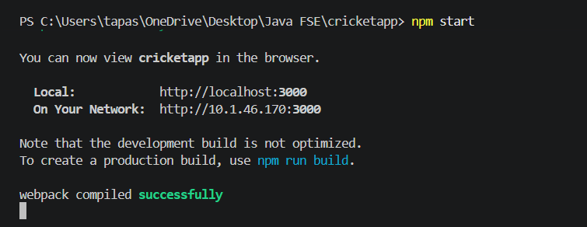

When flag = true
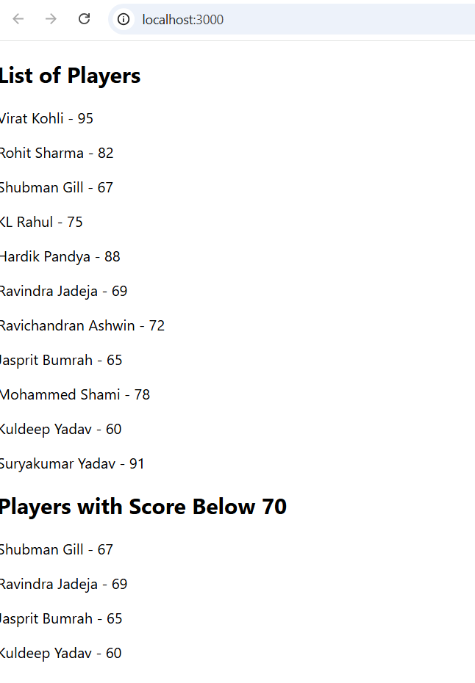

When flag = false
